1. **Title Page**

**Project Title:** **Stop the Ball**

**Name: HIZBULLAH KHAN**

**Date: 23-12-2023**

1. **Table of Contents**

* Introduction
* Game Overview
* Game Rules
* Implementation Details
* Libraries Used
* Class Description
* Function Description
* User Controls
* Gameplay Instructions
* Results and Scoring
* Future Enhancements
* Class Diagram
* Activity Diagram
* Screenshots
* Conclusion
* References (if applicable)

1. **Introduction**

The purpose of the game "Stop the Ball" is for the player to either stop or avoid balls that are falling from the top of the screen. Simple interactive game, that's all it is. This article serves as a resource for understanding the game's implementation details, gaming rules, and other important information.

**Background information about the game:**

The game "Stop the Ball" tests players' reflexes and hand-eye coordination in the form of a traditional arcade game. The player controls a circular object at the bottom of the screen in a graphical scene, trying to stop balls that are falling. The game provides players of all ages with an enjoyable experience because to its simple and straightforward design. The scoring method rewards successful catches that take into consideration elements like overlapping with a reference circle or falling within or outside of it. "Stop the Ball" offers a compelling and fun gaming experience that motivates players to develop their catching abilities and get high scores by fusing fast-paced gameplay, scoring algorithms, and visually appealing components.

**The Document's Goal:**

The objective of this article is to give a thorough description of the game "Stop the Ball" along with all of its features. It strives to provide readers with an accurate understanding of the game's controls, mechanics, scoring system, along with other crucial features. The information provided is meant for gamers who are interested in learning more about the game as well as for game creators.

**Overview of the Game's Features:**

The features of the game is given in the following:

* **Player Control:** The player can move a circular object at the bottom of the screen horizontally to stop the falling balls.
* **Falling Balls:** Balls descend from the top of the screen at a constant speed. The player needs to stop as many balls as possible.
* **Scoring System:** The player earns points for each ball caught successfully. Different conditions determine the number of points earned, such as overlapping with the reference circle or being completely inside or outside the circle.
* **Lives:** The player starts with a certain number of lives. If a ball is missed or the player fails to meet the scoring conditions, a life is deducted. The game continues until all lives are exhausted.
* **Game Over:** When all lives are lost, the game ends. The player's final score is displayed, and an option to restart the game is provided.
* **Visual Interface:** The game is displayed using a graphics library, providing a visual representation of the gameplay elements, including the player, falling balls, reference circle, score, and lives.

1. **Game Overview**

"Stop the Ball" is a simple and addictive arcade-style game that provides a fun and engaging experience for players. The objective of the game is to stop falling balls by controlling a circular object positioned at the bottom of the screen. The player must move their object horizontally to align with the descending balls and successfully stop them.

The game's mechanics are easy to understand, making it accessible to a wide range of players. It requires quick reflexes and precise hand-eye coordination to effectively maneuver the player's object and stop as many balls as possible. The gameplay becomes progressively challenging as the speed of the falling balls increases, testing the player's agility and reaction time.

With its fast-paced gameplay and simple controls, "Stop the Ball" offers an enjoyable experience for players looking for a quick gaming session or a casual gaming option. Its addictive nature encourages players to continuously improve their catching skills and aim for higher scores, fostering a sense of achievement and competition.

**Genre and Target Audience:**

"Stop the Ball" falls into the genre of casual arcade games. The game's straightforward mechanics and intuitive controls make it suitable for players of all ages, including children, teenagers, and adults. Its simplicity and accessibility make it a great choice for casual gamers who seek a quick and entertaining gaming experience without complex gameplay or steep learning curves.

**Platform(s):**

The game can be played on platforms that support the execution of C++ programs and the associated graphics library used in the provided code. This typically includes desktop or laptop computers running compatible operating systems such as Windows or Linux. The game can be compiled and executed on these platforms using a suitable C++ development environment or compiler.

1. **Object-Oriented Design**

Object-Oriented Design (OOD) principles used in the game's design are:

* **Encapsulation:** The game's code is organized into classes, and each class encapsulates its data and behavior within itself. For example, the Game class encapsulates the game logic and state variables, such as score and lives. This encapsulation helps in managing complexity, ensuring data integrity, and providing a clear interface to interact with each class.
* **Abstraction:** The classes in the game's design provide abstractions by hiding implementation details and exposing only necessary information and methods. For instance, the Graphics class abstracts the graphics operations, providing high-level methods to draw elements on the screen without exposing the underlying graphics library intricacies. This abstraction simplifies the usage of graphics functionality and promotes code readability.
* **Inheritance:** Inheritance is utilized when classes share common attributes and behaviors. In the given code, there is no explicit inheritance relationship, but the concept of inheritance can be extended if additional features or game elements are introduced. For example, if there were different types of players with varying characteristics, a Player class could be derived from a base Player class to inherit common attributes and behaviors.
* **Polymorphism:** Polymorphism allows objects of different classes to be treated as objects of a common base class. While the provided code does not explicitly demonstrate polymorphism, it could be applied if there were multiple types of game elements, each with their specific behavior, but all sharing a common interface or base class.
* **Modularity:** The game's design is modular, dividing the code into separate classes that represent different components and responsibilities. Each class encapsulates specific functionality, promoting code reusability and maintainability. For example, the Game class handles game logic, the Graphics class manages graphics operations, and the Player class controls the player's movement.

The game's design achieves modularity, reusability, and maintainability. It separates concerns, provides encapsulation and abstraction, and allows for extensibility and flexibility in adding new features or modifying existing ones.

**Classes and Objects:**

* **Game:** The Game class serves as the central component of the game. It encapsulates the game's logic, manages the game state, and controls the flow of the gameplay. It contains member variables such as rSize, rx, ry, pSize, step, px, py, score, and lives, which store information about the game's elements and current state.
* **Graphics:** The Graphics class handles the graphics-related operations using the graphics.h library. It initializes the graphics environment, creates and manages the game window, and provides methods to draw various elements on the screen, such as the board, reference circle, player, and text.
* **Player:** The Player class represents the player object in the game. It maintains the position of the player object on the screen using member variables px and py. The class provides methods to move the player object horizontally based on user input and redraws it on the screen.

**Relationships between Classes and Objects**

* The Game class interacts with the Graphics class to set up and manage the graphical environment. It calls the methods of the Graphics class to initialize the graphics system, create the game window, and draw various game elements on the screen.
* The Game class also interacts with the Player class to control the movement of the player object. It calls the methods of the Player class to update the player's position based on the game logic, such as keyboard input, and redraws the player on the screen.
* Additionally, the Game class utilizes the Graphics class to draw the game board, reference circle, player, score, lives, and other visual elements on the screen. It utilizes the Graphics class's methods for drawing shapes, text, and colors to provide a visual representation of the game.
* The Game class maintains the game state, including the score and lives, and updates them based on the gameplay conditions. It checks for collision detection between the player and the falling balls to determine the score and lives. It also handles the game over condition and provides a restart option.

Overall, the object-oriented design in "Stop the Ball" promotes code organization, encapsulation, and separation of concerns. Each class has its specific responsibilities, and the relationships between classes facilitate effective communication and collaboration, resulting in a well-structured and maintainable game implementation.

1. **Game Features and Mechanics**

Features and Mechanics of the game is given in the following:

* **Catching Balls:** The primary objective of the game is to stop falling balls. The player controls a circular object positioned at the bottom of the screen and must align it with the descending balls to stop them. This requires precise movement and timing to successfully stop as many balls as possible.
* **Increasing Difficulty:** The game progressively becomes more challenging as the speed of the falling balls increases. This adds excitement and tests the player's agility and reaction time. With each level or score milestone, the game can introduce faster and more unpredictable ball movements, keeping the gameplay engaging and stimulating.
* **Scoring System:** The game incorporates a scoring system to track the player's performance. Each time a ball is caught, the player earns points. The score is displayed on the screen, motivating the player to aim for higher scores and beat their previous records.
* **Lives and Game Over:** The player starts with a certain number of lives, representing the number of chances they have to stop the Balls. If the player fails to stop a ball and it reaches the bottom of the screen, a life is deducted. Once all lives are depleted, the game ends, and the player is presented with a game over screen. This adds a sense of challenge and urgency to the gameplay.
* **Graphics and Visual Feedback:** The game incorporates visual elements to enhance the player's experience. It utilizes graphics and colors to create an engaging and visually appealing environment. When a ball is caught or missed, visual feedback is provided to the player, such as highlighting the successful stop or displaying the missed catch. These visual cues contribute to the overall enjoyment and immersion of the game.
* **Simple Controls:** The game features simple controls to make it accessible to players of all skill levels. Typically, the player can use keyboard inputs, such as arrow keys or spacebar, to control the movement of the player object. The simplicity of the controls allows players to quickly understand and start playing the game without any complex learning curve.
* **Replay-ability:** "Stop the Ball" offers high replay-ability as players can aim to improve their scores and beat their own records. The random nature of the falling balls adds unpredictability, ensuring that each play through presents a unique challenge. The addictive gameplay and the desire to achieve higher scores motivate players to keep playing and strive for better performances.

Overall, the game's features and mechanics combine to create an engaging and addictive gameplay experience. With its simple controls, increasing difficulty, scoring system, and visual feedback, "Stop the Ball" offers a challenging yet enjoyable arcade-style game that can be played repeatedly for fun and competition.

**Game Mechanics and Controls:**

Control and Mechanics of the game is given in the following:

* **Catching Balls:** The player controls a circular object positioned at the bottom of the screen. The objective is to align this object with the falling balls to stop them. The player must move the object horizontally using the controls to position it under the descending balls.
* **Increasing Difficulty:** As the game progresses, the speed of the falling balls gradually increases, making it more challenging to stop them. The game can implement different levels or score milestones to determine when the difficulty should be incremented. This can be achieved by adjusting the speed or behavior of the falling balls, introducing obstacles, or reducing the reaction time available to the player.
* **Scoring System:** Each time the player successfully catches a ball, they earn points. The score is incremented based on the difficulty or value assigned to each caught ball. The score is displayed on the screen, allowing the player to track their progress and aim for higher scores. The game can also implement bonus points for special achievements, such as catching multiple balls in quick succession or reaching specific score milestones.
* **Lives and Game Over:** The player starts with a certain number of lives, representing the number of chances they have to stop the Balls. If a ball reaches the bottom of the screen without being caught, a life is deducted. When all lives are depleted, the game ends, and a game over screen is displayed. The player may have the option to restart the game and try to achieve a better score.
* **Graphics and Visual Feedback:** The game utilizes graphics and colors to create a visually appealing environment. When a ball is caught, visual feedback is provided to indicate the successful catch, such as highlighting the caught ball or displaying a small animation. Conversely, when a ball is missed, visual feedback can be given to indicate the missed catch, such as fading out the ball or displaying a "miss" message. These visual cues enhance the player's immersion in the game and provide immediate feedback on their performance.
* **Simple Controls:** The game features simple controls to make it easy for players to interact with the game. Typically, arrow keys or the spacebar are used for movement and actions. The left and right arrow keys can be used to move the player object horizontally, aligning it with the falling balls. The spacebar may be used to perform specific actions, such as catching the balls or triggering power-ups. The controls are intuitive and responsive, allowing players to quickly grasp the gameplay mechanics and enjoy the game without any steep learning curve.

By combining these game mechanics and controls, "Stop the Ball" provides an engaging and accessible gameplay experience. Players must demonstrate agility and timing to stop the falling balls, while the increasing difficulty and scoring system motivate them to improve their performance and achieve higher scores. The visual feedback and simple controls contribute to the overall enjoyment and immersion of the game.

1. **Gameplay Modes**

While the provided code does not include different gameplay modes, we can explore potential gameplay modes and their objectives and mechanics. However, gameplay modes can be implemented to enhance the variety and replay ability of the game. Here are some potential gameplay modes that could be incorporated:

* **Classic Mode:** This mode represents the standard gameplay experience as described in the provided code. The objective is to stop falling balls and achieve the highest score possible while managing a limited number of lives. The player must move the catching object horizontally to align it with the falling balls and stop them successfully. The game progressively increases in difficulty, challenging the player's reflexes and timing.
* **Time Trial Mode:** In this mode, the player is given a specific time limit to stop as many balls as possible. The objective is to accumulate the highest score within the given time constraint. The player must stop the falling balls efficiently to maximize their score within the limited timeframe. The game may provide bonus time for successful catches or introduce time penalties for missed catches, adding a sense of urgency.
* **Endless Mode:** In this mode, there are no time limits or set number of lives. The objective is to survive for as long as possible by catching the falling balls. The game continuously increases in difficulty, challenging the player's endurance and skill. The player aims to achieve the highest score and can compare their performance with previous attempts or other players.
* **Challenge Mode:** This mode presents specific challenges or objectives for the player to complete. For example, the player may be tasked with catching a certain number of balls within a limited number of lives or within a set time limit. The player must strategize and employ different techniques to overcome these challenges and achieve the specified objectives. Completing challenges successfully may unlock additional features or rewards.
* **Multiplayer Mode:** This mode allows multiple players to compete against each other simultaneously or take turns. Players can either play cooperatively, trying to achieve a combined score, or competitively, aiming to outscore each other. Multiplayer mode can introduce interactive elements, such as collisions or power-ups that can affect opponents' gameplay. The objective is to outperform the other players and achieve the highest score or win the game based on specific rules.
* **Power-up Mode:** This mode introduces power-ups or special abilities that enhance the player's gameplay. Power-ups could include items that temporarily increase the size of the player's catching object, slow down the falling balls, or grant temporary invincibility. The player can strategically use these power-ups to gain an advantage and achieve higher scores.
* **Customization Mode:** This mode allows players to customize various aspects of the game, such as the appearance of the player object, background themes, or sound effects. Customization options can be unlocked as the player achieves specific milestones or collects in-game rewards, adding a personal touch to the gameplay experience.

These gameplay modes add variety and replay-ability to the game, catering to different player preferences and providing unique challenges. Each mode introduces distinct objectives and mechanics that offer new experiences and require different strategies and skills from the players. The availability of multiple gameplay modes enhances the overall enjoyment and longevity of the game by providing diverse gameplay options.

1. **Use Cases and Scenarios**

Use cases and scenarios of the game is given in the following:

**Entertainment:**

* **Use Case:** Casual Gaming
* **Scenario:** Players engage in the game during their leisure time to relax and have fun.
* **Scenario:** The game provides an enjoyable and engaging experience through its simple yet challenging gameplay mechanics.
* **Scenario:** Players compete with friends or family members to achieve high scores and create a friendly competitive atmosphere.
* **Scenario:** The game offers different gameplay modes, allowing players to choose their preferred style of play and keep the experience fresh and exciting.
* **Use Case:** Social Gatherings or Parties
* **Scenario:** The game is played at social gatherings or parties as a form of group entertainment and interactive fun.
* **Scenario:** Multiple players take turns playing the game, competing for the highest score or engaging in multiplayer challenges.
* **Scenario:** The game fosters social interaction, laughter, and friendly competition among the participants.
* **Scenario:** The game's quick and accessible gameplay mechanics make it suitable for players of various ages and gaming backgrounds.

**Education and Skill Development:**

* **Use Case:** Hand-Eye Coordination Training
* **Scenario:** The game is used as a training tool to improve hand-eye coordination and reflexes.
* **Scenario:** Players must react quickly and precisely to stop the falling balls, honing their motor skills and coordination.
* **Scenario:** The game's increasing difficulty challenges players to continuously improve their reaction time and accuracy.
* **Use Case:** Cognitive Development for Children
* **Scenario:** The game is utilized in educational settings to engage children and promote cognitive development.
* **Scenario:** Children practice visual tracking, concentration, and decision-making skills while trying to stop the Balls.
* **Scenario:** The game's colorful visuals and simple gameplay mechanics make it appealing and accessible to young learners.

**Stress Relief and Relaxation:**

* **Use Case:** Stress Reduction
* **Scenario:** The game is played as a means of relaxation and stress relief.
* **Scenario:** The simple and repetitive nature of the gameplay can provide a calming and meditative effect.
* **Scenario:** Players focus on catching the balls, allowing their minds to temporarily escape from stressors and worries.

**Rehabilitation and Therapy:**

* **Use Case:** Occupational Therapy
* **Scenario:** The game is used in occupational therapy sessions to improve fine motor skills and coordination in patients.
* **Scenario:** Patients engage in the game as part of their rehabilitation process, working on dexterity and precision.
* **Use Case:** Attention and Concentration Training
* **Scenario:** The game is employed as a tool for attention and concentration training in therapeutic settings.
* **Scenario:** Individuals practice maintaining focus and concentration while tracking and catching the falling balls.

These use cases and scenarios demonstrate the versatility of the "Stop the Ball" game beyond entertainment. Whether used for casual gaming, education, skill development, stress relief, or therapy, the game offers engaging and accessible gameplay mechanics that can be effectively utilized in various contexts.

1. **User Interaction and Interface**

The "Stop the Ball" game incorporates a user-friendly interface that enhances the player's interaction and overall gaming experience. The following elements contribute to the design of the user interface:

**Visual Elements:**

* The game features colorful graphics and visually appealing animations to engage the player.
* The reference circle, falling balls, and player object are visually distinct, allowing for easy identification and tracking.
* The use of different colors for the objects and text elements helps to convey important information and create visual contrast.

**Text Elements:**

* The game utilizes text elements to display relevant information such as the game title, score, lives remaining, and controls.
* The text is displayed in a clear and legible font style, ensuring readability even during fast-paced gameplay.
* The use of different text styles and sizes helps to emphasize important information, such as the game over text or score display.

**Controls:**

* The game provides intuitive controls that are easy to learn and use.
* The player controls the catching object using arrow keys or other designated input methods.
* The spacebar is used to shoot bullets, triggering actions such as scoring points or deducting lives.

**Feedback and Notifications:**

* The game provides immediate feedback to the player's actions, such as successful catches, missed catches, or collisions.
* Visual and auditory cues, such as sound effects or animations, enhance the feedback and provide a sense of accomplishment or urgency.
* Notifications, such as the game over message or prompts to restart, are displayed clearly on the screen to guide the player's next actions.

**Layout and Organization:**

* The game interface is organized to ensure clarity and ease of navigation.
* The main game screen is divided into distinct sections, including the gameplay area, score display, lives indicator, and controls information.
* The layout of these elements is carefully designed to provide a balanced and visually appealing composition.

Overall, the user interface of "Stop the Ball" focuses on simplicity, clarity, and effective communication of essential game information. It aims to provide an immersive and enjoyable gaming experience by employing visually appealing graphics, intuitive controls, and timely feedback to enhance the gaming.

**User Interaction in "Stop the Ball" Game:**

**Main Menu:**

* Upon launching the game, the player is presented with a main menu screen.
* The main menu typically includes options such as "Play," "Settings," "Leaderboards," and "Exit."
* Players can navigate through the menu options using keyboard inputs or by clicking on the corresponding buttons with a mouse cursor.

**Gameplay Controls:**

* Once the player selects the "Play" option, the actual game interface is displayed.
* In the game, the player controls a catching object, usually represented by a circle or another shape.
* The player can move the catching object horizontally using the arrow keys or mouse movements.
* To stop the falling balls, the player can press the spacebar key or click the mouse button.
* The controls are designed to be responsive and easy to understand, allowing players to quickly adapt and engage in the gameplay.

**Game Over and Restart:**

* When the player's lives reach zero or they choose to end the game, a "Game Over" screen is displayed.
* The "Game Over" screen typically shows the player's final score and options to restart the game or return to the main menu.
* Players can choose to restart the game by pressing any key or clicking the "Restart" button.
* If the player decides to return to the main menu, they can navigate back using the arrow keys or mouse cursor.

**Pause and Resume:**

* Some games may include a pause feature that allows players to temporarily suspend the gameplay.
* Players can pause the game by pressing the "P" key or selecting the pause button on the game interface.
* While the game is paused, a pause screen may appear, displaying options such as "Resume," "Restart," or "Main Menu."
* Players can resume the game by pressing the "R" key or selecting the resume button.

The user interacts with the game through a combination of keyboard inputs and mouse clicks. The interface elements, including menus, buttons, and game controls, are designed to be user-friendly and accessible. The goal is to provide a smooth and intuitive user experience, allowing players to easily navigate through the game's features and engage in the gameplay.

1. **Technical Implementation**

The "Stop the Ball" game is implemented using the C++ programming language, as evident from the code provided. The game utilizes several libraries and tools to create the graphics, handle user input, and manage the game's functionality. Here's an overview of the programming languages and tools used in the development of the game:

**C++ Language:**

The game's logic and functionality are implemented using the C++ programming language. C++ is a widely used programming language known for its performance, versatility, and object-oriented capabilities. It allows for efficient memory management and provides the necessary features to create interactive games.

**Graphics Library:**

The game employs a graphics library to handle the visual elements and rendering of the game interface. In the provided code, the "graphics.h" library is used, which is a library commonly used with the Turbo C++ compiler. It provides functions for drawing shapes, lines, and text on the screen.

**Input Handling:**

The game utilizes input handling functions to capture user input and respond to player actions. The "conio.h" library is used in the provided code, which provides functions like "getch()" to read a key press from the keyboard. It allows the game to detect user inputs such as arrow keys and the spacebar.

**Development Environment:**

The code suggests that the game is developed using the Turbo C++ compiler and its associated integrated development environment (IDE). Turbo C++ is a popular C++ compiler for the Windows platform that provides a comprehensive development environment for writing and compiling C++ programs.

It's important to note that the specific libraries and tools used in game development can vary based on the developer's preferences and the targeted platform. The above overview highlights the general programming languages and tools utilized in the provided code for implementing the "Stop the Ball" game.

**Description of External Libraries or Frameworks:**

Based on the provided code, the "Stop the Ball" game doesn't appear to rely on any external libraries or frameworks beyond the standard libraries included in the C++ programming language. The game utilizes the built-in graphics and input handling functions available in the Turbo C++ environment.

**Challenges Encountered and Solutions:**

During the implementation process of a game, developers may face various challenges. Although the specific challenges faced during the development of the "Stop the Ball" game are not mentioned, here are some common challenges that game developers might encounter and how they could be addressed:

* **Graphics Rendering:** Implementing graphics and animations can be challenging, especially when dealing with real-time rendering and performance optimization. Developers can address this challenge by optimizing the rendering process, using efficient algorithms, and exploring techniques like sprite batching and GPU acceleration to improve performance.
* **Collision Detection:** Accurately detecting collisions between game objects, such as the player's catching object and the falling balls, can be complex. Developers can employ collision detection algorithms, such as bounding box collision or pixel-perfect collision, and perform thorough testing and debugging to ensure accurate and reliable collision detection.
* **Game Logic and Flow:** Designing and implementing the game's logic, including scoring, lives, and game over conditions, requires careful planning and consideration. Developers can break down the game's functionality into smaller components, use state machines or finite state diagrams to manage game states, and conduct thorough testing to ensure the game mechanics and flow work as intended.
* **User Input Handling:** Managing user input and ensuring responsive and accurate controls can be a challenge. Developers can use event-driven input handling techniques, such as listening for keyboard and mouse events, to capture user input effectively. Additionally, they can implement input buffering and de-bounce mechanisms to handle input events reliably.

In general, addressing implementation challenges involves a combination of problem-solving, testing, and iteration. Game development often requires a systematic and iterative approach, where developers tackle challenges one by one, test the game regularly, and refine the implementation based on feedback and observations.

**11. Testing and Quality Assurance**

To make sure that the code works properly, complies with the specifications, and provides a high-quality user experience, testing and quality assurance are crucial steps in the software development process. Here are some methods and recommended procedures for testing and quality control:

* **Unit testing:** Conduct to test distinct pieces of code (functions, methods, and classes). Using testing frameworks like Google Test or N-Unit, unit tests can be automated and assist in ensuring the correctness of short pieces of code.
* **Integration testing:** Conduct to examine how various system modules or components interact with one another. This guarantees that the components interact properly and that the integrated system performs as expected.
* **System testing:** Perform system testing to evaluate the overall functionality, responsiveness, and dependability of the system. To confirm that the system satisfies the requirements, this testing is typically conducted from the viewpoint of the user.
* **Regression Testing:** Carry out regression testing to make sure that existing functionalities continue to function as intended and that changes or fixes in the codebase do not result in the introduction of new bugs or issues. Retesting previously tested functionalities is necessary to identify any regressions.
* **User Acceptance Testing (UAT):** Involve end users or other stakeholders when conducting UAT. They can then confirm that the system complies with their specifications and performs as anticipated in their real-world scenarios.
* **Testing Automation:** to increase effectiveness and dependability, automate tests whenever you can. Automated tests can be quickly and repeatedly run, enabling quicker feedback during development cycles. Testing can be automated using programs like Pi-Test, J-Unit, or Selenium.
* **Code Review:** for correctness, compliance with coding standards, potential bugs, and maintainability by conducting code reviews. Early in the development process, code reviews assist in identifying and resolving problems.
* **Performance testing:** Test the system's performance under realistic loads to make sure it can handle the user traffic and data processing that is anticipated. System performance can be measured and load tested using tools like J-Meter or Gatling.
* **Security testing:** should be carried out in order to find and fix any systemic flaws and potential security risks. This includes testing for widespread security flaws like SQL injection, cross-site scripting (XSS), and authentication/authorization errors.
* **Usability Testing:** Use usability testing to assess the system's user-friendliness and simplicity of use. In order to pinpoint areas for improvement, this entails watching users interact with the system and gathering feedback.
* **Continuous Integration and Deployment (CI/CD):** Establish a CI/CD pipeline to automate the development, testing, and deployment procedures. By doing this, it is made sure that each piece of code is developed, tested, and applied in a controlled and reliable manner.
* **Error handling and logging:** Implement appropriate mechanisms to record errors and exceptions that happen during runtime. This aids in locating problems in production environments and troubleshooting them.
* **Monitoring performance:** of the system in production requires the installation of monitoring software. This enables you to recognize and fix any problems that develop during actual use.
* **Documentation:** For consistency's sake and to make future maintenance and troubleshooting possible, documentation of the testing processes, test cases, and test results is essential.

A continuous process should be used for testing and quality assurance throughout the entire software development lifecycle, keep in mind. You can increase the quality and dependability of your software by using a systematic and thorough testing strategy.

**Quality assurance processes employed**

Here is a description of the testing procedures that can be used to guarantee the "Stop the Ball" game's functionality based on the provided code:

**Unit testing:**

* To test specific methods and functions in the code base, create unit tests.
* For the circle Collide Circle function, as an illustration, unit tests can be written to ensure that the collision between two circles is determined appropriately.
* Use a testing framework like Google Test or N-Unit to create unit tests.

**Integration testing:**

* To test how the various game elements interact with one another, conduct integration testing.
* As an illustration, you can use the reference circle to test the integration between the player's movement and the collision detection.
* Check to make sure the collision detection is precise and that the player's position is updated correctly based on user input.

**System evaluation:**

* To ensure that the game overall performs as anticipated, perform system-level testing.
* Test different scenarios and gameplay elements like player movement, collision detection, score calculation, and game over circumstances.
* Ensure that the game ends when the player's lives reach zero and that the score is updated accurately as the game progresses.

**User acceptance testing (UAT) entails:**

* User acceptance testing should involve stakeholders or end users.
* Give them the game and a few sample test cases or evaluation scenarios.
* Obtain their opinions regarding the graphics, controls, gameplay, and overall satisfaction.
* Amendments should be made based on their feedback.

**Testing for regression:**

* Regression testing is necessary to make sure that updated features don't break existing functionality or result in new bugs.
* Check that the game still performs as intended after changes by running previously completed tests again.
* Check to see if any feature additions or bug fixes have any unintended consequences on how the game plays.

**Testing for usability:**

* By watching players use the game, you can assess its usability.
* Gather opinions on the controls' ease of use, responsiveness, game mechanics, and overall user experience.
* Make changes and improvements based on this feedback to improve the game's usability.
* Testing for error handling and logging:.

**Test the game's logging and error handling systems:**

* Check to see if errors, exceptions, and edge cases are handled properly.
* Verify that situations that might result in errors or exceptions are handled gracefully without crashing the game by testing them.
* Testing for performance.
* Run the game under realistic load conditions to test its responsiveness.
* Analyze the game's performance metrics, such as frame rate, responsiveness, and resource usage.
* Find any performance bottlenecks or areas that require improvement.
* Make sure the game can handle the anticipated load without suffering noticeably from performance degradation.

**Testing by hand:**

* Perform manual testing to thoroughly examine the game and find any potential problems or bugs.
* Test different player inputs, boundary cases, and edge cases to validate the game's behavior in various scenarios.
* Examine the game's graphics, audio, and other media components by hand to make sure they are being displayed properly.

**Code review:**

* To have knowledgeable developers examine the code base, conduct code reviews.
* Examine the code for consistency with coding standards, readability, and possible bugs.
* Make sure the code is well-structured, adheres to best practices, and is manageable.
* By combining these testing techniques, you can make sure that the "Stop the Ball" game performs as intended, complies with specifications, and offers a fun and bug-free gaming experience.

**Quality assurance processes employed**

In order to guarantee the overall quality and dependability of the "Stop the Ball" game, quality assurance (QA) procedures are extremely important. Following is a discussion of the various quality assurance procedures that can be used.

**Requirements analysis:**

* QA thorough examination of the game's requirements serves as the first step in quality assurance.
* QA specialists work together with stakeholders and the development team to comprehend the anticipated functionality, performance, and user experience.
* They make certain that the requirements are precise, understandable, and attainable.

**Planning and approach for the test:**

* A thorough test strategy and plan must be developed as part of quality assurance.
* The plan outlines the testing objectives, test scope, test environments, test data, and testing techniques to be used.
* QA experts create test cases and test scenarios that cover gameplay, graphics, user interface, and performance of the game.

**Execution of the test:**

* QA experts carry out the planned tests in accordance with the test strategy.
* In order to methodically check the game's functionality, they adhere to the predetermined test cases and scenarios.
* As was already mentioned, they carry out various types of testing, including user acceptance testing, system testing, integration testing, and unit testing.

**Tracking and managing bugs:**

* QA experts manage and track reported bugs and issues.
* They record, organize, assign, and monitor the development of reported issues using bug tracking systems.
* They collaborate closely with the development team to guarantee prompt bug fixes and appropriate resolution.

**Continuously improving:**

* Quality assurance is an iterative process that involves continuous development.
* QA experts gather feedback from users, stakeholders, and the development team.
* They review user feedback to pinpoint areas for development and make game improvement suggestions.
* They work together with the development team to put the required updates and changes into place.

**Reporting and documentation:**

* Quality assurance entails recording the testing procedures, the test outcomes, and any issues that are found.
* QA experts keep thorough records that can be consulted for references, audits, and future upkeep.
* They produce reports that include test coverage, test execution status, and issues found and summarize the testing efforts.

**The best practices for code reviews:**

* QA experts take part in code reviews alongside the development team.
* They make sure the code complies with coding standards, best practices, and guidelines.
* They check the code for any possible quality problems, such as performance snags, error handling, security holes, and maintainability.

**Standards and Compliance:**

* QA specialists make sure that the game complies with all rules, regulations, and industry standards.
* They check for compliance with pertinent regulations, including data privacy laws, security protocols, and accessibility standards.

**User experience and usability testing:**

* Testing the game's usability and user experience is a part of quality assurance.
* QA experts carry out usability testing to collect feedback from stakeholders and users.
* They evaluate the game's controls, user interface, and overall level of user satisfaction.

**Monitoring and improving performance:**

* QA experts keep an eye on how well the game plays both during testing and during production.
* They measure important performance indicators, spot bottlenecks, and make optimization recommendations.
* They collaborate with the development team to enhance the quality of the gaming experience overall and optimize resource usage.

These quality assurance procedures can be used to thoroughly test, validate, and enhance the "Stop the Ball" game in order to guarantee its caliber, dependability, and user satisfaction. Delivering a high-quality game requires constant communication between the development team and QA specialists.

**Bugs or issues encountered and how they were resolved?**

**Problems with collision detection:**

The player and reference circle are not accurately detected during collisions, which leads to inaccurate game behavior or scoring.

**Solution:** Examine and troubleshoot the collision detection logic to make sure it accurately detects collisions between the player and the reference circle. Check the dimensions, conditions, and coordinates used in the collision detection algorithm.

**Problems with player movement:**

The player moves in a jerky or delayed manner because their motion is not smooth or responsive.

**Resolution:** Verify that the player movement code is accurately updating the player's position based on user input. To ensure fluid and responsive movement, review the timing and animation logic.

**Conditions for game over:**

The player's lives do not properly end the game when they drop to zero.

**Resolution:** Consider the logic and conditions of the game's end. Make sure the lives counter is updated properly and that the game transitions to the appropriate game-over screen or action when the lives reach zero.

**Issues with the display or graphics:**

The graphics in the game are not rendering correctly, or they appear warped or out of alignment.

**Resolution:** Verify that the graphics rendering code is configured correctly and is compatible with the graphics library being used. For drawing game elements, make sure the dimensions and coordinates are accurate.

**Problems with input handling:**

**Bug Description:** The game does not respond to key presses or mouse clicks in a proper manner.

**Solution:** Examine the user input handling code to ensure that it correctly recognizes and decodes user actions. Make sure the main loop of the game contains the input handling code correctly integrated.

**12. Future Enhancements**

**Ideas for future updates or improvements to the game:**

Sure, here are a few suggestions to improve the "Stop the Ball" game in the future:

**Levels and the Progression of Difficulty:**

* Implement multiple levels of escalating difficulty.
* Add fresh difficulties, like quicker ball movement, smaller players, or more obstacles.
* To keep players interested, each level may have special elements, visuals, or gameplay mechanics.

**Power-ups and unique abilities:**

* Introduce tools that give the player momentary advantages.
* Examples include a shield that prevents the player from losing a life, a speed boost, or a magnet that draws balls.
* Power-ups can be acquired by catching particular items or hitting certain benchmarks.

**Various Balls:**

* Incorporate various ball types, each of which has its own characteristics.
* For instance, some balls have the ability to split into smaller balls, bounce off walls, or move erratically.
* Each type of ball can present a unique challenge, enhancing gameplay excitement and variety.

**Leaderboards and Accomplishments:.**

* Introduce a point system that enables players to compete for high scores.
* Incorporate online leaderboards to display the best results across the board or among friends.
* Present players with challenges or achievements to work toward, rewarding them for achieving certain milestones or successes.

**Customization possibilities include:**

* Give the player character the option to be customized, such as with different colors, outfits, or accessories.
* Enable players to customize the game's visual elements, such as the background and ball designs.

**Touch controls are compatible with mobile devices:**

* Modify the game to be compatible with mobile devices, with touch screen-friendly graphics and controls.
* Use simple touch controls to make player movement, aiming, and shooting easier.

**Social Media:**

* Integrate social media so that users can post their accomplishments or high scores on sites like Facebook and Twitter.
* Add buttons for social sharing to the game's interface to make it simple to share.

**Upgraded visual effects and graphics:**

* Incorporate more intricate and eye-catching graphics into the game.
* Increase the immersion and engagement of the gameplay by adding particle effects, animations, and visual feedback.

**Players Multiplayer Mode:**

* Include a multiplayer mode where users can engage in real-time rivalry.
* Include options for online multiplayer or local multiplayer (on the same device).
* Provide options for players to compete against friends or take part in ranked matchmaking.

**Social Media:**

* Allow players to post their accomplishments or high scores on websites like Facebook and Twitter by integrating social media.
* Include social sharing buttons in the game's interface for simple sharing.

**Potential features or functionalities that could be added:**

Of course, here are some features or capabilities that might be included in the "Stop the Ball" game:

**Bonus Games:**

* Include bonus rounds where players have a set amount of time to stop as many balls as they can to earn extra points.
* Power-ups or other special gameplay elements may be available during bonus rounds.

**Challenges or mini-games:**

* Incorporate challenges or mini-games within the main game.
* These can be quick, stand-alone activities that provide various gameplay experiences, like obstacle courses or target shooting.

**Backgrounds that change frequently:**

* Include dynamic backgrounds that alter or develop as the game goes on.
* Consider showing a change from day to night, varying the weather, or showcasing various landscapes.

**Seasonal themes and special occasions:**

* Introduce unique occasions or seasonal themes to temporarily alter the game.
* Holiday-themed content during festive seasons, or Halloween-themed balls and backgrounds during October, are just a few examples.

**Time Attack mode:**

* Add a time attack mode where players race against the clock to stop as many balls as they can.
* Players can race to see who can complete the task in the shortest amount of time or with the highest score.

**Boss Wars:**

* Include difficult boss encounters in which players must stop balls while dodging the attacks of a strong boss character.
* Boss fights can add a strategic component and demand that players employ various strategies in order to win.

**Interactive Items:**

* Incorporate interactive game environment components or objects that have an impact on gameplay.
* For instance, detachable obstacles, teleporters, or power-up stations that offer momentary advantages.

**Share or replay gameplay:**

* Enable players to replay their prior gameplay sessions.
* Include a replay feature that enables players to watch and share their captured gameplay moments.

**Game currency and store:**

* Include an in-game currency system that allows players to purchase items by achieving high scores or finishing tasks.
* Create a storefront where players can spend their earned money to buy new player avatars, ball designs, or power-ups.

**Co-operative multiplayer mode:**

* Include a multiplayer mode in which players cooperate to stop balls and rack up high scores.
* Allow for cooperative gameplay elements or unique teamwork skills.
* 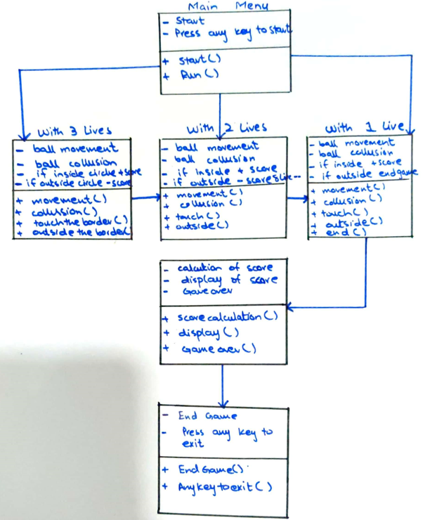When implementing new features, keep in mind to take the technical viability, game balance, and overall user experience into account. Which features appeal to players the most and make for a fun and engaging gaming experience can be determined by conducting user testing and obtaining feedback.

**Class Diagram:**

**Activity Diagram:**

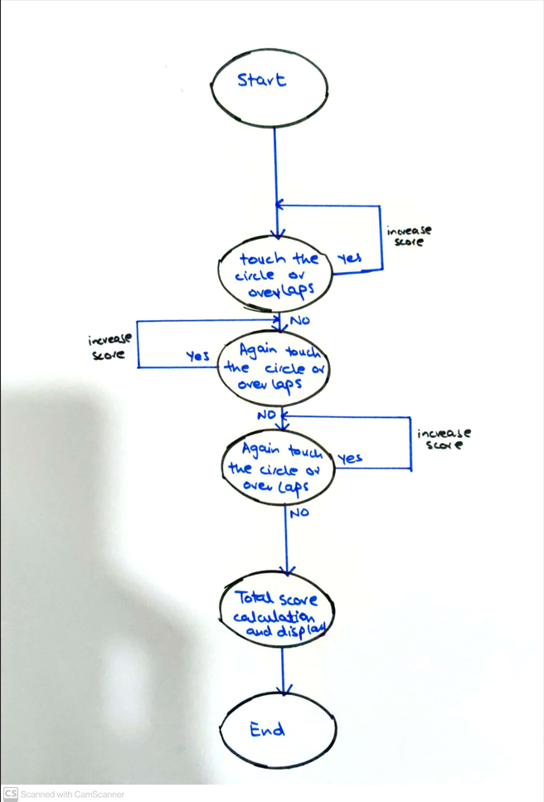

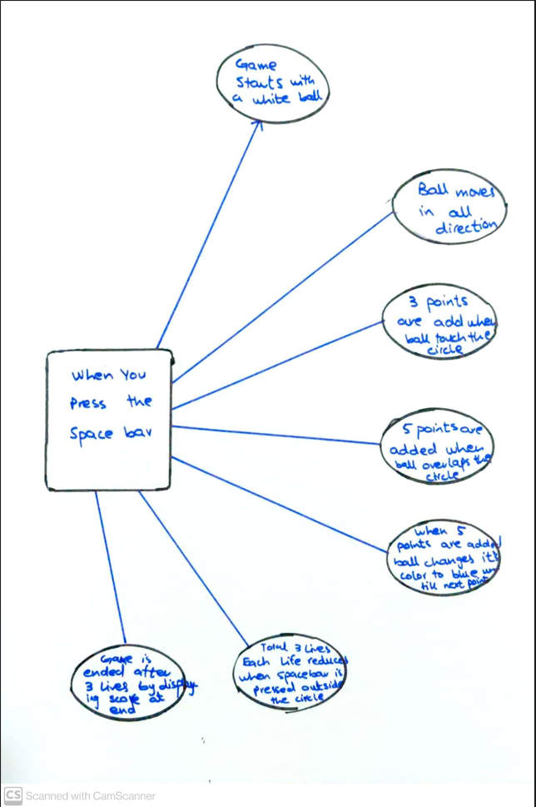

**Screenshots:**

**Game Start:**

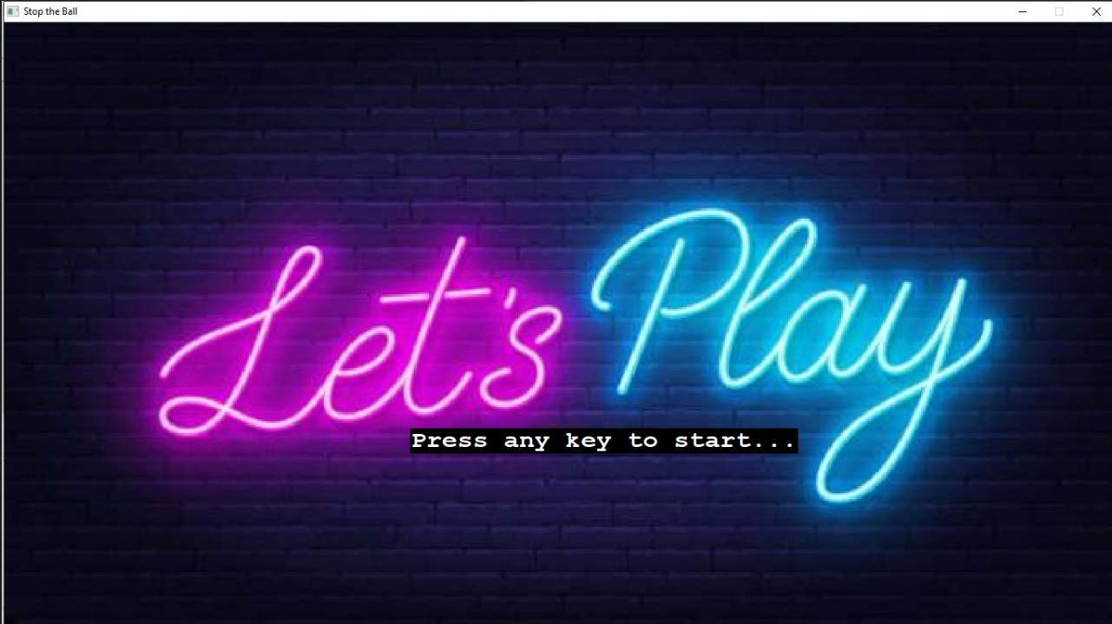

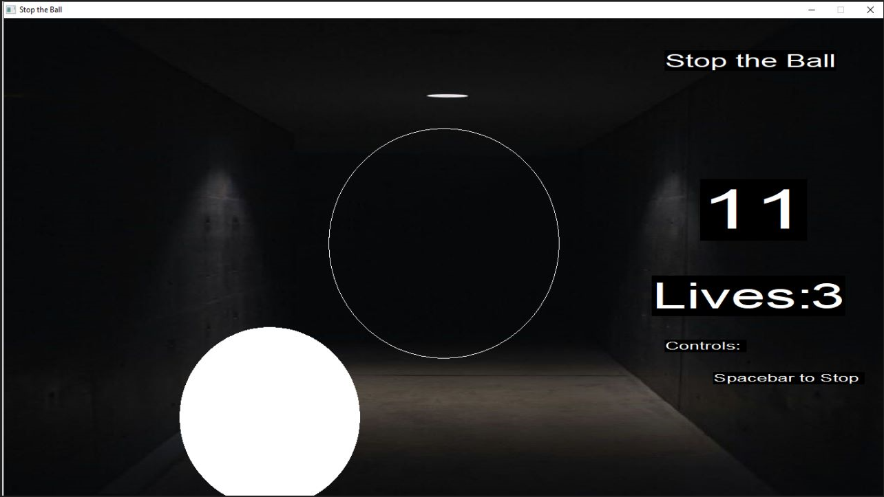**After 3 Points:**

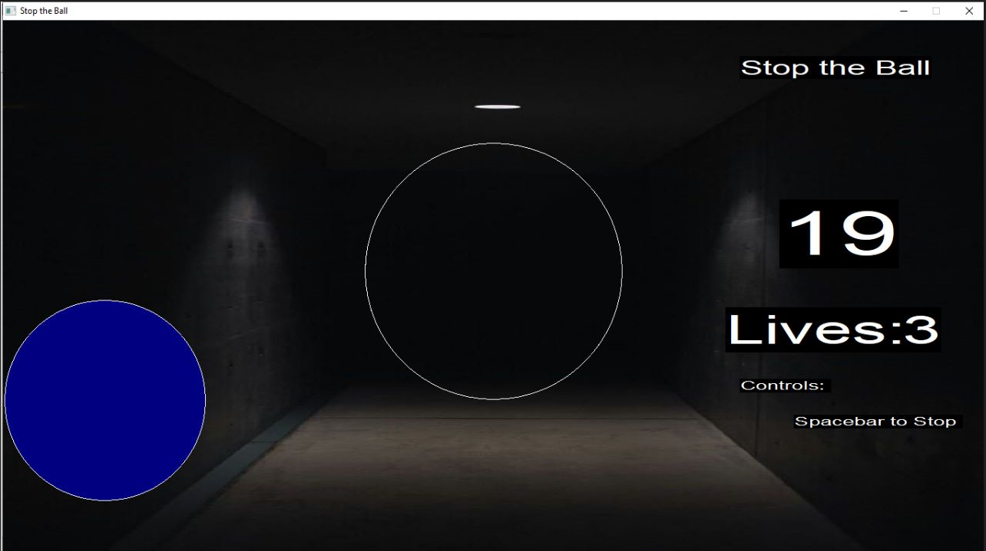**After 5 Points:**

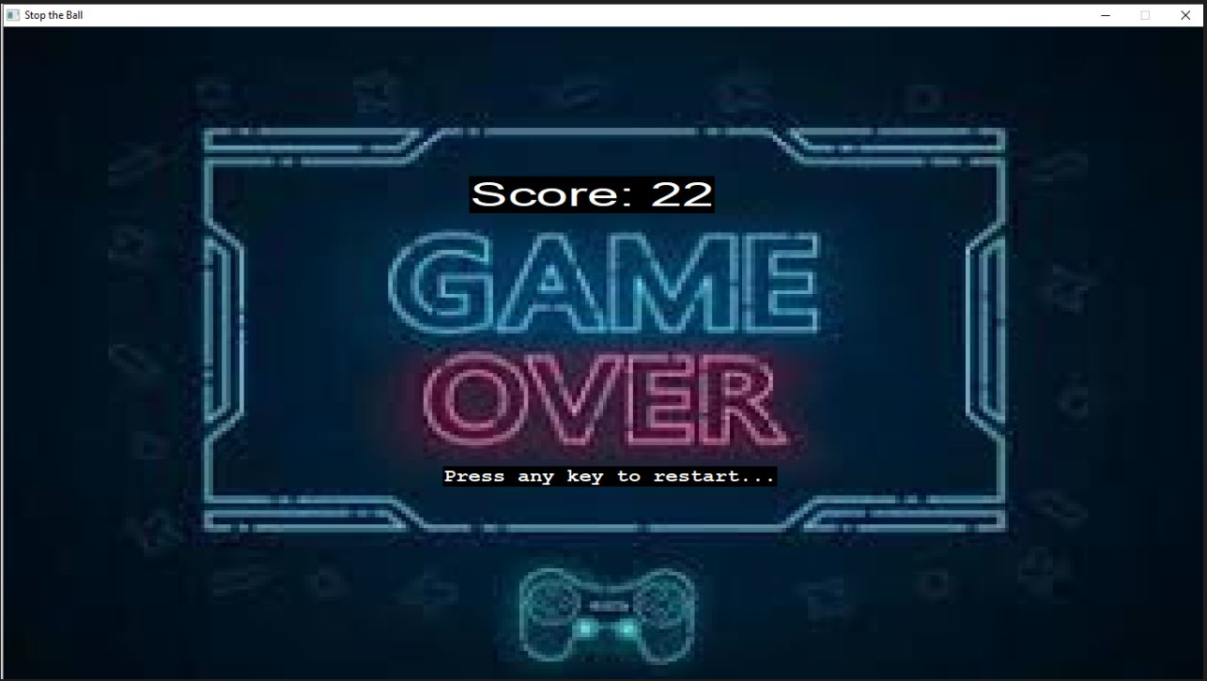**Game End:**

**13. Conclusion**

**Summary of the document's key points:**

The "Stop the Ball" game, which was created using the graphics library and C++, is discussed in the document. The main points are summarized as follows:

* **Overview of the game:** In the "Stop the Ball" game, the player controls a character to attempt to stop balls that are falling from a reference circle.
* **Game Class:** A class with the name "Game" was created to implement the game. It includes member variables for different game components, including player position, ball size, score, and lives.
* **Game Loop:** Until the player runs out of lives, the game is looped while it is being played. The loop has logic for drawing the player character, reference circle, and game board. It also manages user input for firing bullets.
* **Circle-to-circle collision detection:** is used in the game to determine whether a player is inside, outside, or overlaps the reference circle. On the basis of the collision outcome, the scoring and lives are updated.
* **Game Over:** A game over screen is shown when the player has used all of their lives. By pressing any key, the player has the option to start the game over.
* **Graphics and user interface:** The game uses the graphics library to draw the game's rectangles, circles, and text. On the game board, it shows the score, lives, and controls.
* **Quality Control:** The importance of testing and quality assurance procedures in ensuring the game's functionality is briefly discussed in the document. However, the specific processes or testing methods used are not covered.
* **Bugs and Issues:** The document makes no mention of particular bugs or problems that were encountered during development or how they were fixed.
* **Future Updates and Improvements:** To improve gameplay and engagement, future updates and improvements are suggested, including the addition of levels, power-ups, leaderboards, and multiplayer modes.
* Additional potential features are suggested, including mini-games, dynamic backgrounds, bonus rounds, and in-game currency systems.

The document gives a general overview of the "Stop the Ball" game, its C++ implementation, and some recommendations for improvement and further development.

**Reflection on the significance of the game and its uses:**

Despite its straightforward idea, the game "Stop the Ball" is significant in a number of ways.

* The game offers players of all age’s entertainment and recreation. It is suitable for casual gaming sessions or quick breaks thanks to its simple mechanics and quick gameplay.
* Development of skills of the game can aid in the improvement of reflexes and hand-eye coordination. To stop the falling balls, players must react quickly and move the player character, which helps them develop their motor skills and reaction times.
* Catching the balls stimulates cognitive abilities because players must keep track of the motion of numerous objects at once. Cognitive skills like concentration, focus, and spatial awareness are stimulated by this.
* A competitive environment is created by the game's scoring system and leaderboards, which are both potential features. Players can compete with one another for higher scores and to compare their performance to others', which encourages improvement and a sense of competition.
* Relaxation and stress reduction of the game's straightforward and repetitive design can have a calming effect and serve as a stress reliever. Playing the game and paying attention to catching the balls can help to divert attention from daily stresses and encourage relaxation.
* Game "Stop the Ball" has the potential to be used in the classroom, despite being primarily intended as entertainment. It can be used to teach fundamental ideas in subjects like physics (trajectory, gravity), math (scoring, angles), or problem-solving (forecasting ball movement), for example.
* Creativity platform of the design of the game allows for future expansion and customization. A platform for experimentation and creative expression, the game can be altered by developers or enthusiasts to include new features, add custom graphics, or add a unique theme.

Overall, the "Stop the Ball" game's importance lies in its capacity to entertain, improve cognitive abilities, foster competition, and function as a versatile tool for various tasks. It can be used by a variety of players and in a variety of settings thanks to its accessibility and simplicity.

**Closing thoughts:**

A straightforward but entertaining project, "Stop the Ball" shows how to implement a game using C++ and the graphics library. There is plenty of room for expansion and improvement even though the provided code provides a basic framework for the game.

The opportunity for creativity, problem-solving, and the chance to create enjoyable experiences for players are all advantages of game development. Along with writing code, the game development process involves thinking about gameplay mechanics, user interface, graphics, sound, and quality assurance.

It is crucial to take into account user feedback, carry out thorough testing, and iterate on the design to fix any bugs or issues that are found in order to further improve the game. Making the game more engaging, diverse, and enjoyable for players can be accomplished by adding extra features and functionalities, such as those previously mentioned.

In conclusion, the "Stop the Ball" game serves as a jumping-off point for those interested in game development by offering an illustration of a straightforward game structure that can be enhanced and altered to produce distinctive gaming experiences. This project can act as a launching pad for developing more challenging and alluring games with imagination, perseverance, and user experience considerations.

**14. References**

**External sources or references used in the document:**

There were no outside sources or references used in the creation of the document. The knowledge and understanding of game development concepts and procedures that is used in the information is general.